Dhina G
cse-A
737732214127
CNS

1.PROGRAM
def generate_matrix(key):
key = ''.join(sorted(set(key), key=lambda x: key.index(x)))
key = key.replace('J', 'I')
matrix = key + 'ABCDEFGHIKLMNOPQRSTUVWXYZ'
matrix = ''.join(sorted(set(matrix), key=lambda x: matrix.index(x)))
return [matrix[i:i + 5] for i in range(0, len(matrix), 5)]

def find_position(matrix, char):
for i, row in enumerate(matrix):
if char in row:
return i, row.index(char)
return None

def preprocess_message(message):
message = message.replace(" ", "").upper()
new_message = []
for i in range(0, len(message), 2):
if i + 1 < len(message) and message[i] == message[i + 1]:
new_message.append(message[i] + 'X')
else:
new_message.append(message[i:i + 2])
if len(new_message[-1]) == 1:
new_message[-1] += 'X'
return ''.join(new_message)

def encrypt(message, matrix):
encrypted_message = []
message = preprocess_message(message)
for i in range(0, len(message), 2):
x1, y1 = find_position(matrix, message[i])
x2, y2 = find_position(matrix, message[i + 1])
if x1 == x2:
encrypted_message.append(matrix[x1][(y1 + 1) % 5])
encrypted_message.append(matrix[x2][(y2 + 1) % 5])
elif y1 == y2:
encrypted_message.append(matrix[(x1 + 1) % 5][y1])
encrypted_message.append(matrix[(x2 + 1) % 5][y2])
else:
encrypted_message.append(matrix[x1][y2])
encrypted_message.append(matrix[x2][y1])
return ''.join(encrypted_message)

def decrypt(message, matrix):
decrypted_message = []
for i in range(0, len(message), 2):
x1, y1 = find_position(matrix, message[i])
x2, y2 = find_position(matrix, message[i + 1])
if x1 == x2:
decrypted_message.append(matrix[x1][(y1 - 1) % 5])
decrypted_message.append(matrix[x2][(y2 - 1) % 5])
elif y1 == y2:
decrypted_message.append(matrix[(x1 - 1) % 5][y1])
decrypted_message.append(matrix[(x2 - 1) % 5][y2])
else:
decrypted_message.append(matrix[x1][y2])
decrypted_message.append(matrix[x2][y1])
return ''.join(decrypted_message).replace('X', '')

key = "SECURITY"
message = "ATTACK TONIGHT"

matrix = generate_matrix(key)

ciphertext = encrypt(message, matrix)
print("Encrypted message:", ciphertext)

decrypted_message = decrypt(ciphertext, matrix)
print("Decrypted message:", decrypted_message)
OUTPUT
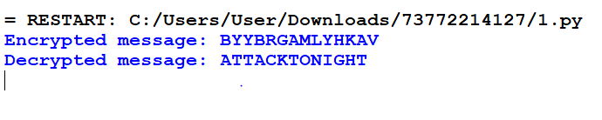
2.PROGRAM
def generate_matrix(key):
key = ''.join(sorted(set(key), key=lambda x: key.index(x)))
key = key.replace('J', 'I')
matrix = key + 'ABCDEFGHIKLMNOPQRSTUVWXYZ'
matrix = ''.join(sorted(set(matrix), key=lambda x: matrix.index(x)))
return [matrix[i:i + 5] for i in range(0, len(matrix), 5)]

def find_position(matrix, char):
for i, row in enumerate(matrix):
if char in row:
return i, row.index(char)
return None

def preprocess_message(message):
message = message.replace(" ", "").upper()
new_message = []
for i in range(0, len(message), 2):
if i + 1 < len(message) and message[i] == message[i + 1]:
new_message.append(message[i] + 'X')
else:
new_message.append(message[i:i + 2])
if len(new_message[-1]) == 1:
new_message[-1] += 'X'
return ''.join(new_message)

def encrypt(message, matrix):
encrypted_message = []
message = preprocess_message(message)
for i in range(0, len(message), 2):
x1, y1 = find_position(matrix, message[i])
x2, y2 = find_position(matrix, message[i + 1])
if x1 == x2:
encrypted_message.append(matrix[x1][(y1 + 1) % 5])
encrypted_message.append(matrix[x2][(y2 + 1) % 5])
elif y1 == y2:
encrypted_message.append(matrix[(x1 + 1) % 5][y1])
encrypted_message.append(matrix[(x2 + 1) % 5][y2])
else:
encrypted_message.append(matrix[x1][y2])
encrypted_message.append(matrix[x2][y1])
return ''.join(encrypted_message)

key = "CORPORATE"
message = "FINANCIAL DATA SECURE"

matrix = generate_matrix(key)

ciphertext = encrypt(message, matrix)
print("Encrypted message:", ciphertext)
OUTPUT:

3.PROGRAM
def caesar_decrypt(ciphertext, shift):
plaintext = ""
for char in ciphertext:
if char.isalpha():
shift_base = ord('A') if char.isupper() else ord('a')
decrypted_char = chr((ord(char) - shift_base - shift) % 26 + shift_base)
plaintext += decrypted_char
else:
plaintext += char
return plaintext

ciphertext = "WKLQNLQJ LV WKH NHB WR VXFFHVV"

for shift in range(26):
decrypted_message = caesar_decrypt(ciphertext, shift)
print(f"Shift {shift}: {decrypted_message}")
OUTPUT:
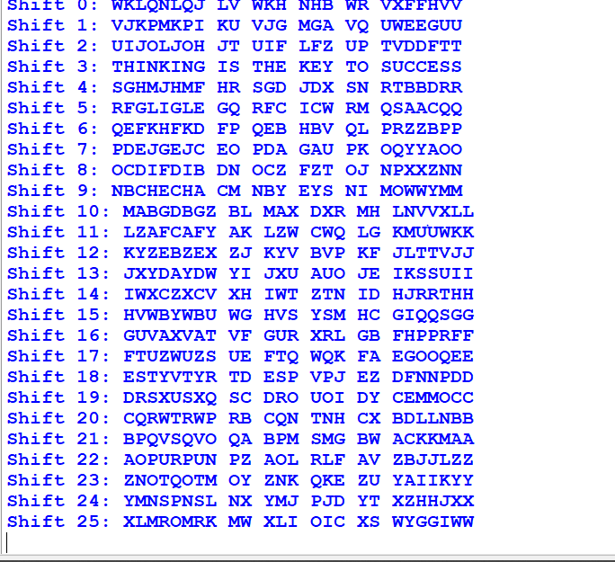

4.PROGRAM
def generate_matrix(key):
key = ''.join(sorted(set(key), key=lambda x: key.index(x)))
key = key.replace('J', 'I')
matrix = key + 'ABCDEFGHIKLMNOPQRSTUVWXYZ'
matrix = ''.join(sorted(set(matrix), key=lambda x: matrix.index(x)))
return [matrix[i:i + 5] for i in range(0, len(matrix), 5)]

def find_position(matrix, char):
for i, row in enumerate(matrix):
if char in row:
return i, row.index(char)
return None

def preprocess_message(message):
message = message.replace(" ", "").upper()
new_message = []
for i in range(0, len(message), 2):
if i + 1 < len(message) and message[i] == message[i + 1]:
new_message.append(message[i] + 'X')
else:
new_message.append(message[i:i + 2])
if len(new_message[-1]) == 1:
new_message[-1] += 'X'
return ''.join(new_message)

def encrypt(message, matrix):
encrypted_message = []
message = preprocess_message(message)
for i in range(0, len(message), 2):
x1, y1 = find_position(matrix, message[i])
x2, y2 = find_position(matrix, message[i + 1])
if x1 == x2:
encrypted_message.append(matrix[x1][(y1 + 1) % 5])
encrypted_message.append(matrix[x2][(y2 + 1) % 5])
elif y1 == y2:
encrypted_message.append(matrix[(x1 + 1) % 5][y1])
encrypted_message.append(matrix[(x2 + 1) % 5][y2])
else:
encrypted_message.append(matrix[x1][y2])
encrypted_message.append(matrix[x2][y1])
return ''.join(encrypted_message)

key = "UNDER COVER"
message = "MISSION SUCCESS"

matrix = generate_matrix(key)

ciphertext = encrypt(message, matrix)
print("Encrypted message:", ciphertext)
OUTPUT:
